Power BI Capstone Project Dashboard Report

# Question 1: Top Categories by Total Sales

## Question Statement:

Identify and visually represent the top 10 product categories by total sales.

## Visualization:

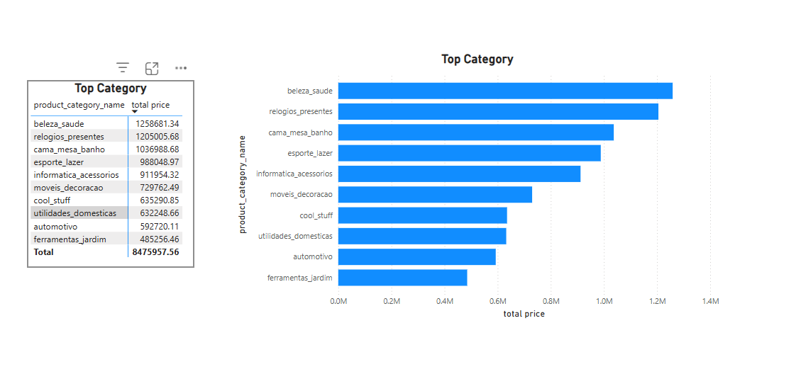

## Explanation:

The above visualization displays the top 10 product categories based on the total sales (total price). The horizontal bar chart clearly shows that 'beleza_saude' and 'relogios_presentes' are the leading categories, with sales exceeding 1.2 million each. Other notable categories include 'cama_mesa_banho' and 'esporte_lazer'. The visual allows stakeholders to quickly understand which product categories contribute most significantly to revenue, which can guide inventory, marketing, and sales strategies.

# Question 2: Delayed Orders Analysis

## Question Statement:

Determine the number of delayed orders in each category. An order is considered delayed if the actual delivery date is later than the estimated delivery date.

## Visualization:

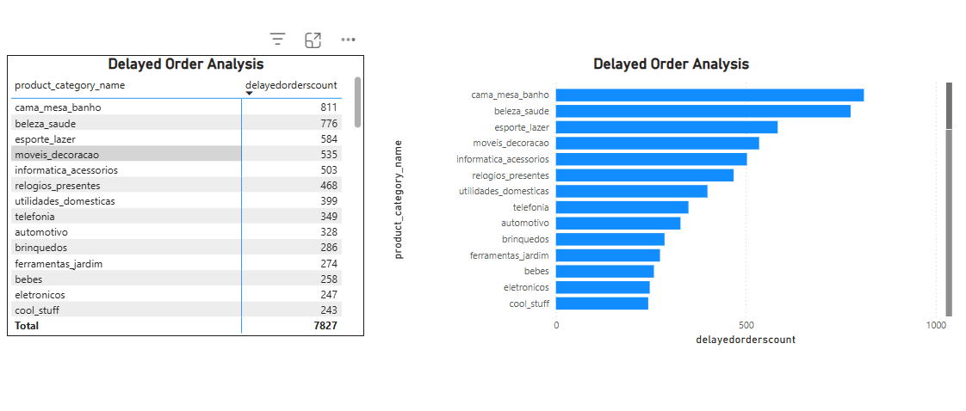

## Explanation:

The visualization presents the number of delayed orders for each product category. The bar chart and table indicate that 'cama_mesa_banho' and 'beleza_saude' have the highest number of delayed orders, with 811 and 776 delays respectively. Other categories such as 'esporte_lazer', 'moveis_decoracao', and 'informatica_acessorios' also show a significant number of delays. These insights can help identify which categories may require improvements in supply chain, logistics, or vendor performance to reduce delays.

# Question 3: Monthly Comparison of Delayed and On-Time Orders

## Question Statement:

Create a dynamic visual that compares the number of delayed orders to the number of orders received earlier for each month. Utilize drillthrough cross-report feature to provide a detailed analysis of late and on-time deliveries.

## Visualization:

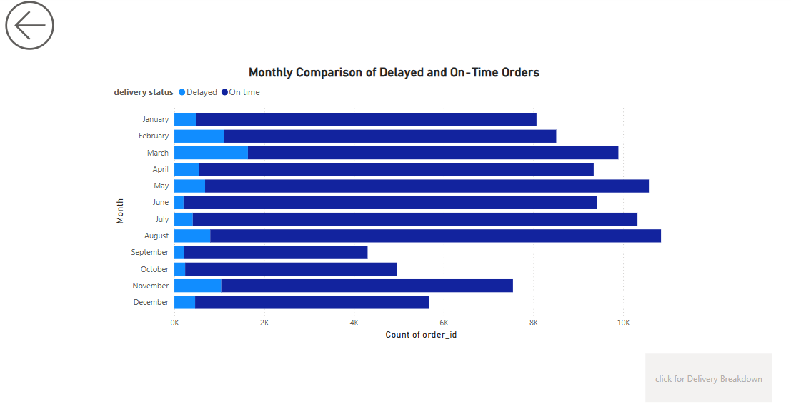

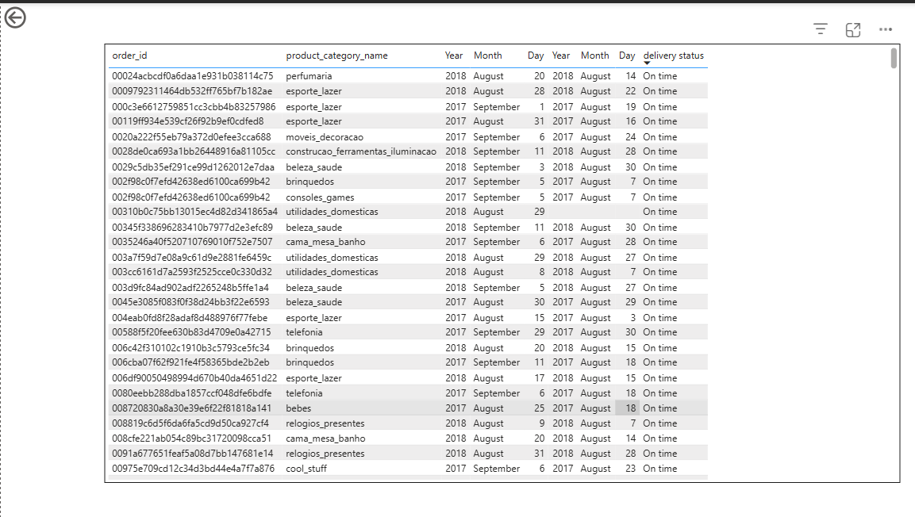

## Explanation:

The monthly comparison visualization displays the count of delayed and on-time orders across each month of the year. It highlights how the delivery performance changes month to month. February,March, and November show a noticeable number of delayed orders (light blue), though most months are dominated by on-time deliveries (dark blue). The detailed drillthrough table provides order-level insights for each month, showing delivery dates, product categories, and delivery status. This enables businesses to perform root cause analysis on delays and identify patterns or bottlenecks specific to certain months or categories.

## Question 4: Payment Method Analysis Question Statement

The analysis below highlights the most frequently used payment methods by customers. The visual representation (pie chart) provides a clear breakdown of each payment type and its corresponding share.

## Visualization

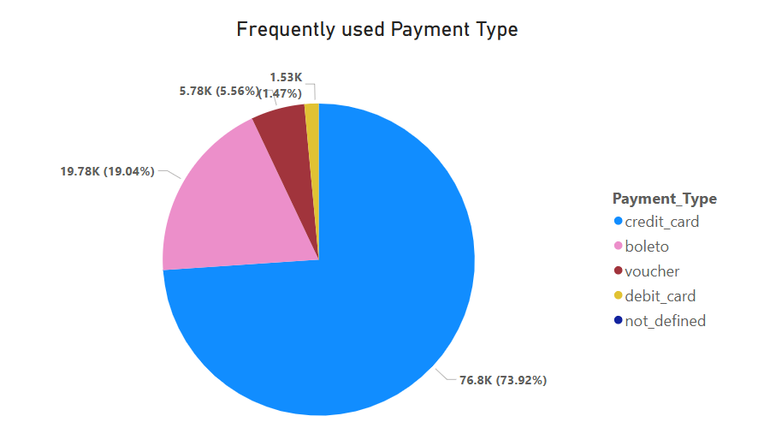

Key Insights:  
- Credit Card is the most used payment method, accounting for 73.92% of all transactions.  
- Boleto comes in second with 19.04%.  
- Other methods like Voucher, Debit Card, and Undefined account for a small portion of transactions.

# Question5 - Product Rating Analysis

## Question Statement

This analysis identifies the top 10 highest-rated and bottom 10 lowest-rated product categories based on average customer ratings. Bar charts and tables are used to clearly display the distribution of average ratings across these product categories.

## Visualization

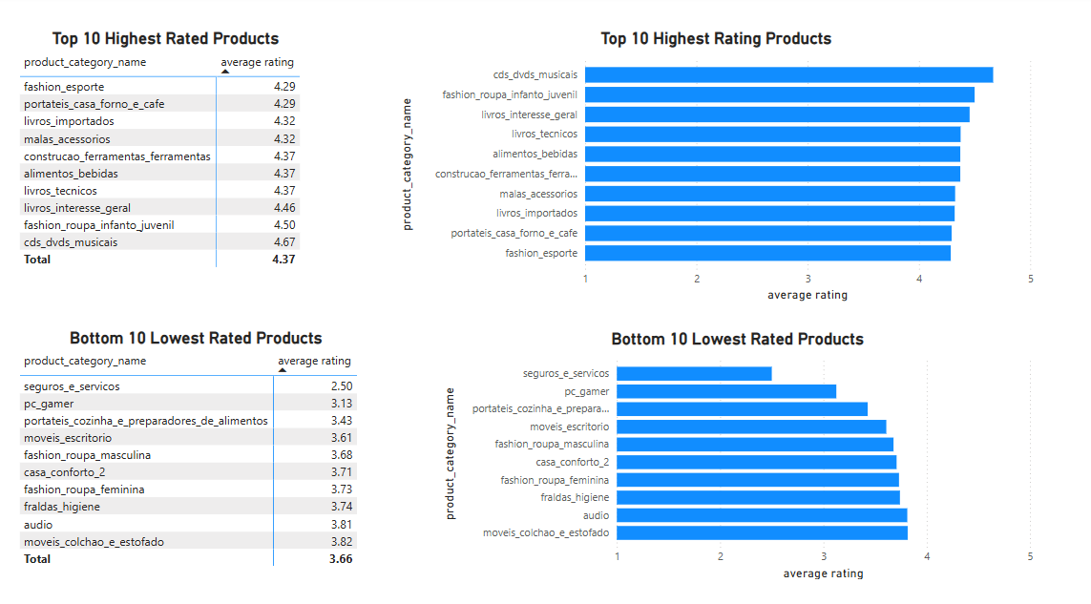

Key Insights:  
- The highest-rated product category is 'cds_dvds_musicais' with an average rating of 4.67.  
- Other top-rated categories include 'fashion_roupa_infanto_juvenil', 'livros_interesse_geral', and 'alimentos_bebidas'.  
- The lowest-rated product category is 'seguros_e_servicos' with an average rating of 2.50.  
- Other low-rated categories include 'pc_gamer', 'portateis_cozinha_e_preparadores_de_alimentos', and 'moveis_escritorio'.

# Question6 - State-wise Sales Analysis

### Question Statement:

State-wise Sales Analysis: Identify and visually represent states with high and low sales, providing a clear understanding of regional sales performance.

### Visualization:

Below are the dashboard screenshots used for the state-wise sales analysis:

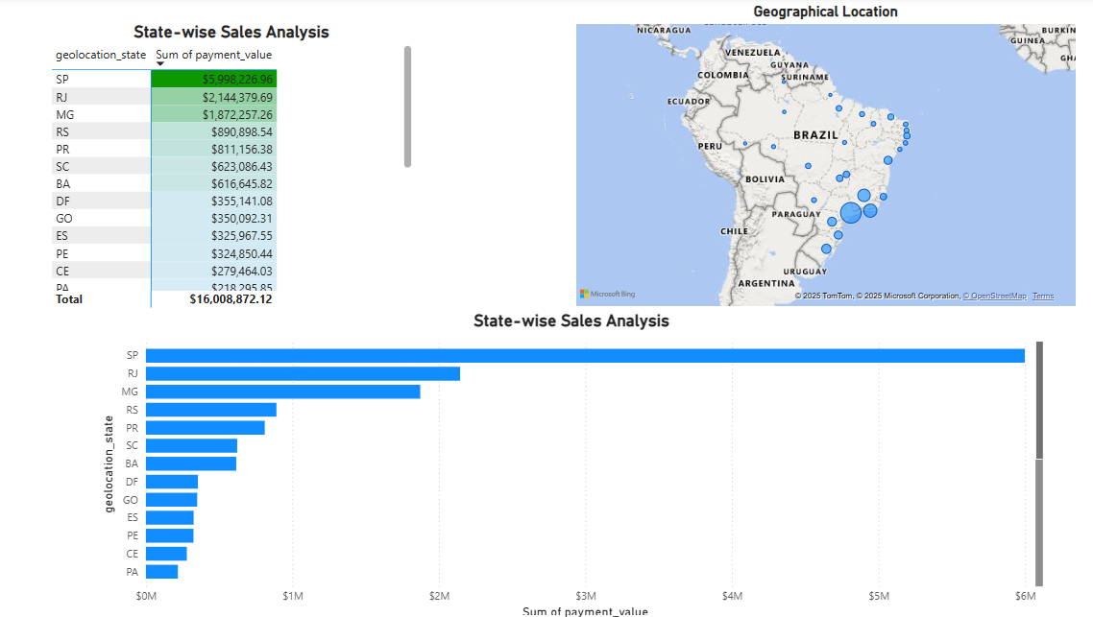

Figure 1: State-wise sales distribution (Top selling states).

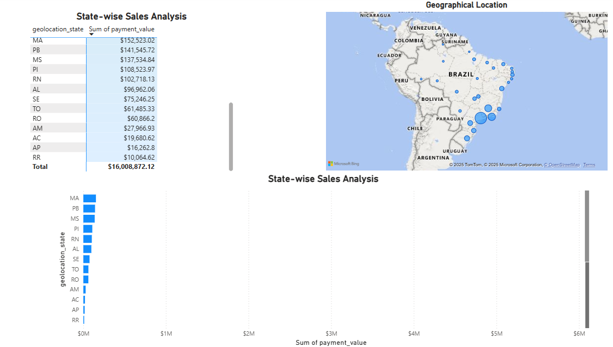

Figure 2: State-wise sales distribution (Lowest selling states).

### Explanation:

The dashboard provides a comprehensive analysis of sales performance across various Brazilian states. Three visualizations are used:  
  
1. Table View: Summarizes the total sales (payment_value) for each state.  
2. Bar Chart: Clearly compares sales across states, making it easy to identify high and low performing states.  
3. Geographical Map: Visually maps the sales volume geographically using proportional circle markers.  
  
Key insights:  
- Highest Sales: Sao Paulo (SP) leads significantly with over $5.99M in sales, followed by Rio de Janeiro (RJ) and Minas Gerais (MG).  
- Lowest Sales: States like Roraima (RR), Amapa (AP), and Acre (AC) recorded the lowest sales, each contributing less than $20K.  
- The visualization effectively highlights regional disparities in sales, helping businesses target marketing or logistics improvements.

# Question7 - Seasonal Sales Patterns

## Question Statement:

Investigate and visualize any seasonal patterns (quarterly) or trends in sales data over the course of the year.

## Visualization:

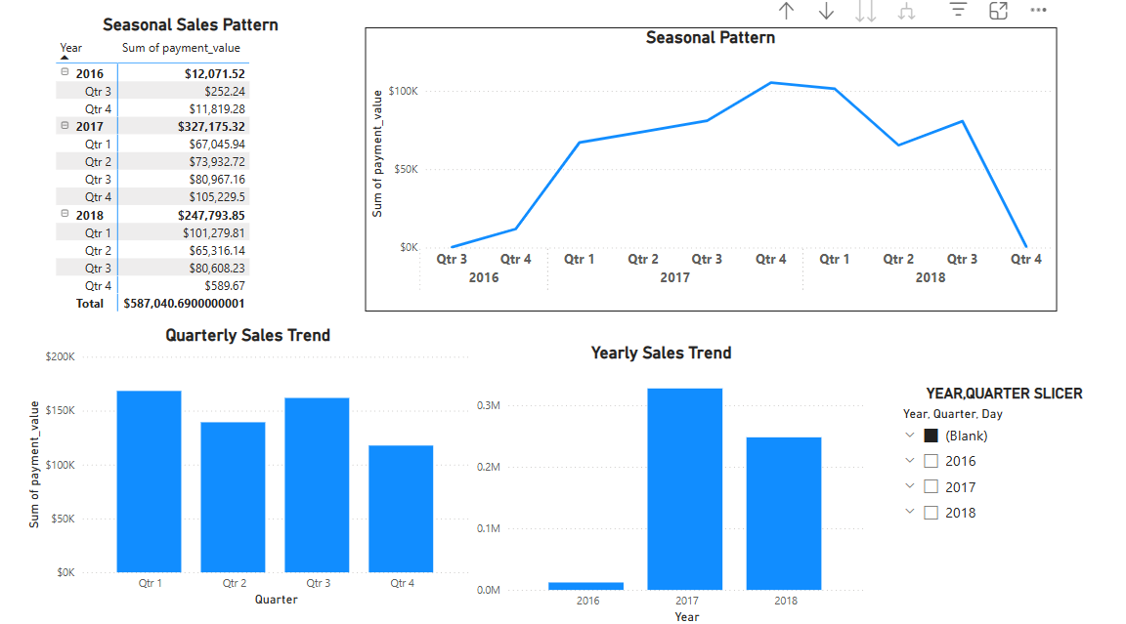

## Explanation:

The visualizations above explore seasonal patterns in sales from 2016 to 2018. The line chart titled 'Seasonal Pattern' illustrates quarterly sales trends across these years. From the chart, Q4 of 2017 shows the highest sales, while Q3 of 2016 and Q4 of 2018 reflect the lowest. The bar chart 'Quarterly Sales Trend' aggregates sales across all years by quarter, indicating Q1 and Q3 as peak seasons, while Q4 lags slightly. The 'Yearly Sales Trend' confirms 2017 as the best-performing year, with over $327K in sales. This seasonal trend analysis helps identify peak business periods and informs strategic planning.

# Question8 - Revenue Analysis

Question statement  
Determine the total revenue generated by ShopNest Store and analyze how it changes over time (yearly).

## Visualization

• A line chart demonstrates the upward trend in revenue over the years.

• A bar chart provides a clear comparison of total yearly revenue.

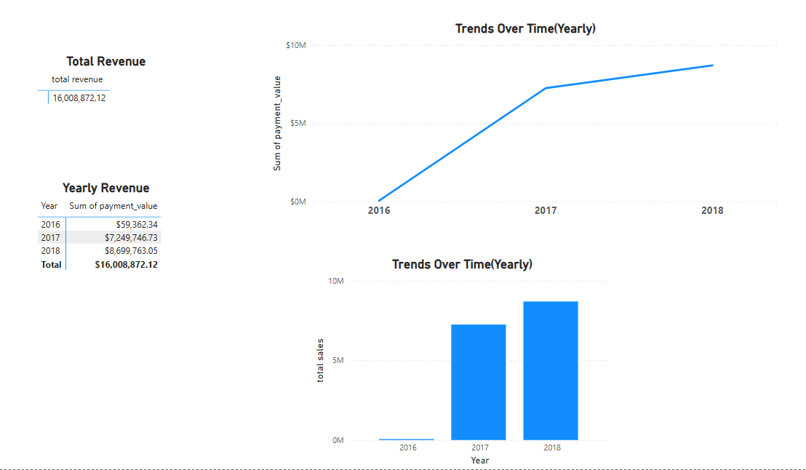

Explanation  
The visualizations display the yearly revenue and trends in total revenue over the three-year period from 2016 to 2018.

## Key Insights

• Total revenue generated: $16,008,872.12

• 2016: $59,362.34

• 2017: $7,249,746.73

• 2018: $8,699,763.05

• There is a significant increase in revenue from 2016 to 2017, followed by continued growth in 2018.